|  |
| --- |
| **Name: NEHA ANTONY**  **Roll No: 23**  **Batch: B**  **Date: 01/04/2022** |

**NETWORKING & SYSTEM ADMINISTRATION LAB**

**Experiment No.: 4**

**Aim**

Familiarization of the linux commands.

**Procedure**

**1 cut -d ‘ ‘**

If -d option is used then it considered space as a field separator or delimiter:

Syntax :- $ cut -d ‘ ‘ f2 filename

Output :-

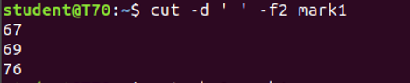

# 2. cut -b

To extract the specific bytes, you need to follow -b option with the list of byte numbers separated by comma. Range of bytes can also be specified using the hyphen(-). It is necessary to specify list of byte numbers otherwise it gives error. **Tabs and backspaces** are treated like as a character of 1 byte.

Syntax :- $ cut -b 2 filename

Output :-

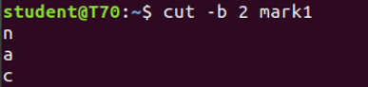

# 3. cut –complement

As the name suggests it complement the output. This option can be used in the combination with other options either with **-f** or with **-c**.

Syntax :- $ cut –complement -c 1 filename

Output :-

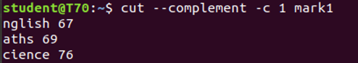

# 4. paste

Paste command is one of the useful commands in Unix or Linux operating system. It is used to join files horizontally (parallel merging) by outputting lines consisting of lines from each file specified, separated by **tab** as delimiter, to the standard output.

Syntax :- $ paste filel file2

Output :-

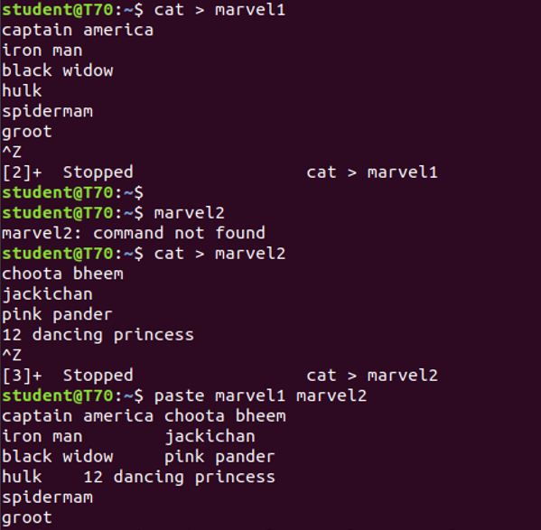

**5. Paste -d (delimiter):**

Paste command uses the tab delimiter by default for merging the files. The delimiter can be changed to any other character by using the **-d** option. If more than one character is specified as delimiter then paste uses it in a circular fashion for each file line separation.

Syntax : $paste -d ‘-‘ file1 file2

Output:-

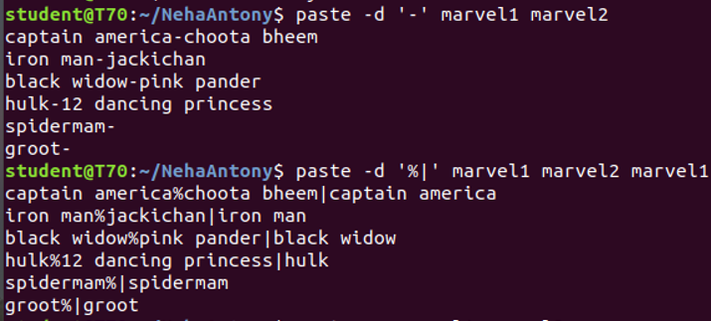

**6.Paste -s (serial):**

 We can merge the files in sequentially manner using the -s option. It reads all the lines from a single file and merges all these lines into a single line with each line separated by tab. And these single lines are separated by newline.

Syntax : $paste -s file1 file2

Output:-



# 7. paste file1 file2 > file3

First and second files are merged into a third file.

Output:-

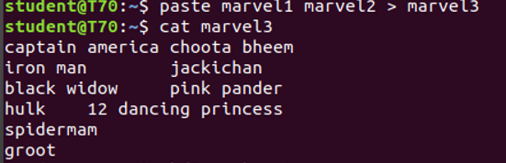

# 8. more :

more command is used to view the text files in the command prompt, displaying one screen at a time in case the file is large (For example log files). The more command also allows the user do scroll up and down through the page.

**SPACE Key** is act as a NEXT button.

**B Key** act as a PREVIOUS button.

**ENTER** **key** is used to view line by line.

Syntax :- $more filename

Output :-

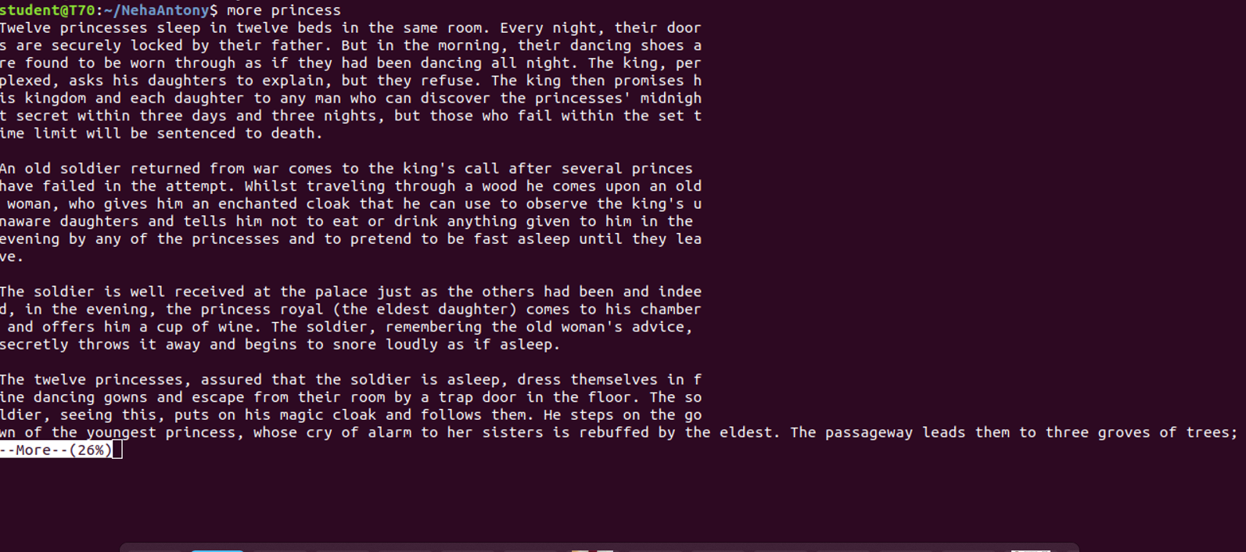

# 9. more -s :

This option squeezes multiple blank lines into one single blank line.

Syntax :- $more -s filename

Output :-

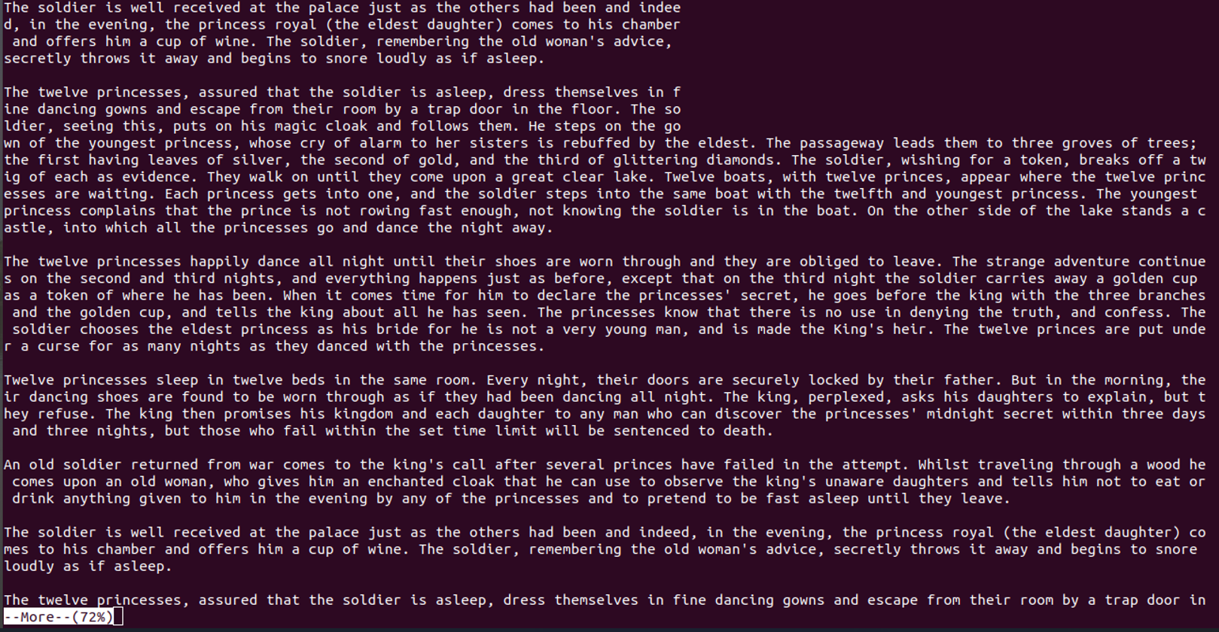

# 10. ****more +n :****

# This option displays the text after the specified number of lines of the document.

Syntax :- $ more +n filename

Output :-



# 11. more -n :

type the number of lines that you want to display per screen.

Syntax :- $ more -n filename

Output :-

